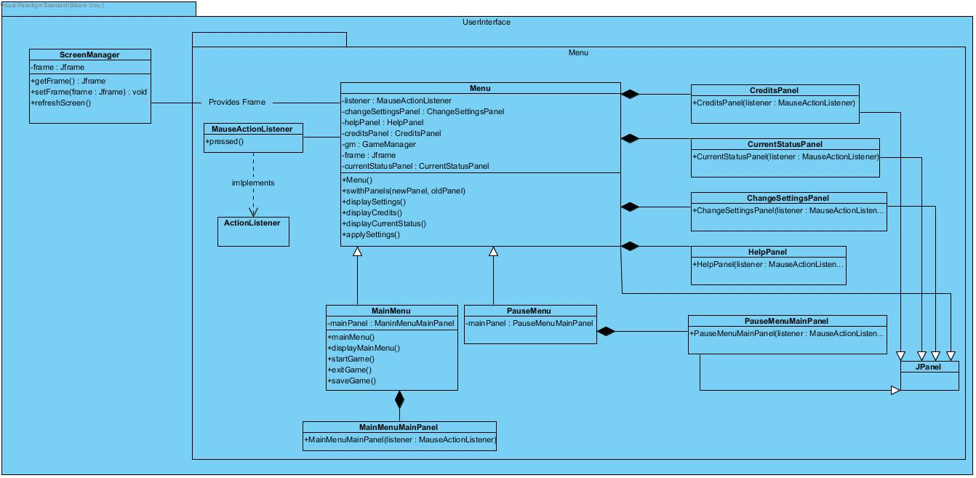**User Interface Subsystem Design**

**Screen Manager Class**

**Functions**

|  |  |
| --- | --- |
| Class Name : ScreenManager | Explanation of functions |
| Public getFrame(): JFrame | Returns the current frame |
| Private setFrame(frame: JFrame) : void | Sets a new frame. |
| refreshScreen() | Refreshes the frame after setting one new frame. |

Main action of this class is to provide a screen image for MainMenu. It will be provided by JFrame and it can be changed and refreshed.

**Menu Class**

Menu class is the class which has different classes that should be displayed inside of the menu. Attributes of this class is explained as following :

**Attributes**

|  |  |
| --- | --- |
| Class Name : Menu | Explanation of attributes |
| listener : MauseActionListener | To listen related user action on Menu |
| changeSettingsPanel : ChangeSettingsPanel | ChangeSettingsPanel will provide the settings of the game |
| helpPanel: HelpPanel | Include main instructions of the game |
| creditsPanel : CreditsPanel | Credits interface will also be available |
| gameManager : GameManager | Game Manager will be controlling the game |
| frame : JFrame | Provides menu frame. |
| currentStatusPanel:CurrentStatusPanel | Show the current status of game. |

These attributes will be used inside of the functions Menu class. These functions are explained as following :

**Functions**

|  |  |
| --- | --- |
| Class Name : Menu | Explanation of functions |
| Menu() | This is the menu providing function. |
| switchPanels(newPanel, oldPanel) | If pressed to one button on the menu then this function will take the input and change the panel from the old panel. |
| displaySettings() | This will be used when settings button is pressed |
| displayCurrentStatus() | This function will be used when the settings button is pressed. This will navigate to the CurrentStatusPanel. |
| applySettings() | This will send the acitons that are made by user on Settings page to GameManager to change the current settings. |

**Pause Menu**

This is the menu that will be able to be accessed from the game page. This Pause Menu will have following functions. This function will connect to the main menu so it’s actions will be done.

**Functions**

|  |  |
| --- | --- |
| Class Name : PauseMenu | Explanation of functions |
| mainPanel:PauseMenuMainPanel | This will navigate to mainPanel and will let user do main menu actions. |

**Main Menu**

Main menu is the menu that will enable the user to interact with the game with selecting new game or reloading the last saved one, saving the current status of game, exiting game. Main Menu’s functions are explained bellow :

**Functions**

|  |  |
| --- | --- |
| Class Name : MainMenu | Explanation of functions |
| mainMenu() | Returns the current frame |
| displayMainMenu() | Sets a new frame. |
| startGame() | Refreshes the frame after setting one new frame. |
| exitGame() | Exits the game. |
| saveGame() | Saves the current status of game. |